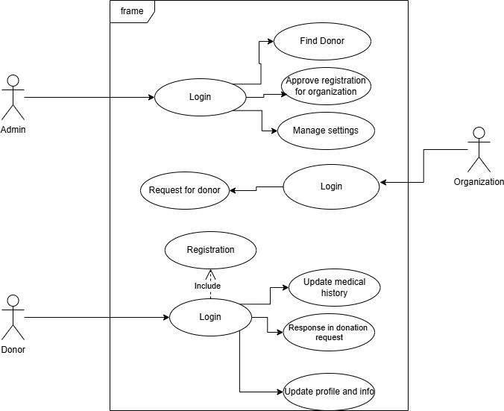
f
Admin
Donor
frame
Find Donor
Login
Approve registration for organization
Manage settings
웃
Request for donor
Login
Organization
Registration
Include
Login
Update medical history
Response in donation request
Update profile and info)

